Docker Enabled status :
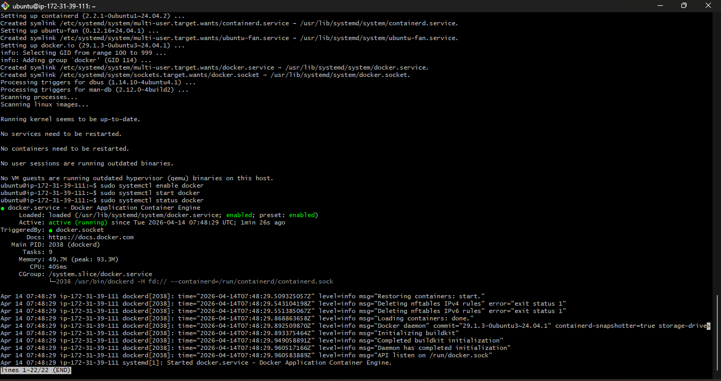
Kubectl installed :
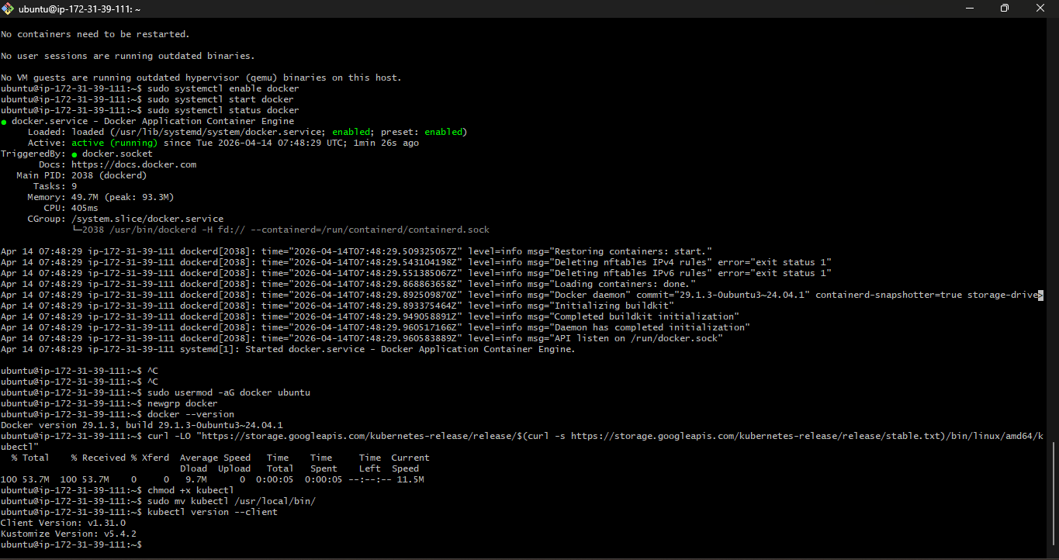
MiniKube Installed:
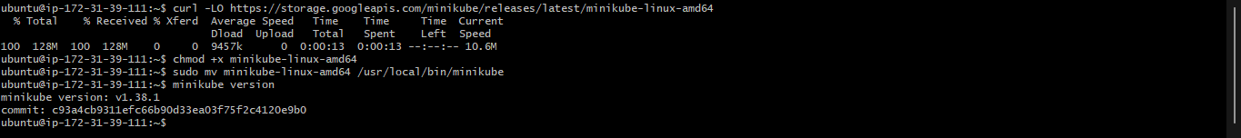

Unable to do this with minikube. For this t2.medium or higher instance type is needed to do this task. Free tier AWS doesn’t allow this to do. Hence provided the RAW output which done for Kubernetes task -2.
